# Tasks to Perform

## **4. Retrieve total approved claim amounts per hospital.**

### **A. Query Codes**

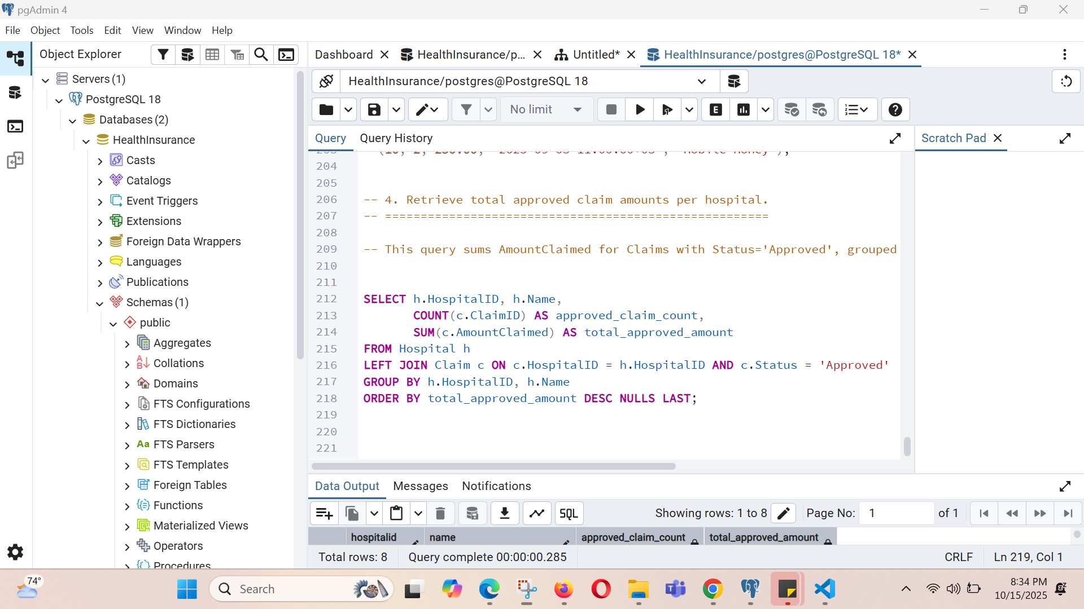

### **B. Result.**

